Lab Assignment 7

Chaudhary Hamdan

1905387

Date: 16-03-2022

1. [Create Lists ,Tuples, Dictionaries and Sets](https://www.datacamp.com/community/tutorials/18-most-common-python-list-questions-learn-python" \l "question1).Print elements stored in each case.

li = [1, 2, 3]

tu = (1, 2, 3)

di = {1: 'a', 2: 'b', 3: 'c'}

se = {1, 2, 3, 1, 3}

for ele in li:

print(ele, end=', ')

print()

for ele in tu:

print(ele, end=', ')

print()

for key in di:

print(key, ':', di[key], end=', ')

print()

for ele in se:

print(ele, end=', ')

print()

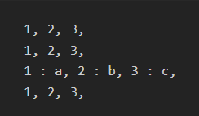

2.I) [Select the Element kept at 2 nd position. From a List](https://www.datacamp.com/community/tutorials/18-most-common-python-list-questions-learn-python" \l "question2) and display it.

Ii)create numpy array by already existing list and display its datatype and dimension.

li = [1, 2, 3]

pos = 2

print(li[pos-1])

print()

import numpy as np

nli = np.array(li)

print(nli.dtype)

print(nli.ndim)

print(nli.shape)

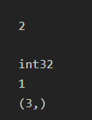

1. Use range function to generate values with name RangeVar. Keep lower bound as 1, higher bound 50. and each value should have difference of 10.

RangeVar = list(range(1, 50+1, 10))

print(RangeVar)

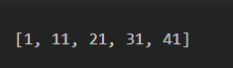

1. Create a string ‘Techniquelab’. Find out the character at 5th position. Find out the index of ‘l’ in the string.

s = 'Techniquelab'

pos = 5

print(s[pos-1])

print(s.index('l'))

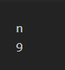

1. In 3rd question, the values populted in RangeVar.Find out if 11 exists and also find out the value at 3rd index.

RangeVar = list(range(1, 50+1, 10))

print(11 in RangeVar)

idx = 3

print(RangeVar[idx])

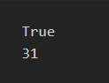

1. Create a list with values 100, ‘Alice’, 12 and ‘Programmer’.Display the whole list.Then add value ‘Python’ to the list and display the modified list.

li = [100, 'Alice', 12, 'Programmer']

print(li)

li.append('Python')

print(li)

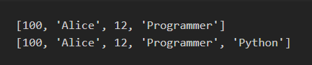

1. Create a tuple with values:100, ‘Alice’, 12 and ‘Programmer’.Display the tuple.Then add values ‘Python’ and ‘ML’ to it and display the modified tuple.

tu = (100, 'Alice', 12, 'Programmer')

print(tu)

tu = tuple(list(tu) + ['Python', 'ML'])

print(tu)

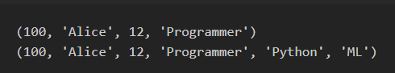

8.In the tuple with values :100, ‘Alice’, 12 and ‘Programmer’,print the values from index 0 to 2 ,getting displayed on console thrice.

tu = (100, 'Alice', 12, 'Programmer')

for i in range(3):

for j in range(3):

print(tu[j], end=', ')

print()

